Software Overview:
For any application development, it all starts with Idea. Requirements get written to achieve /develop app.
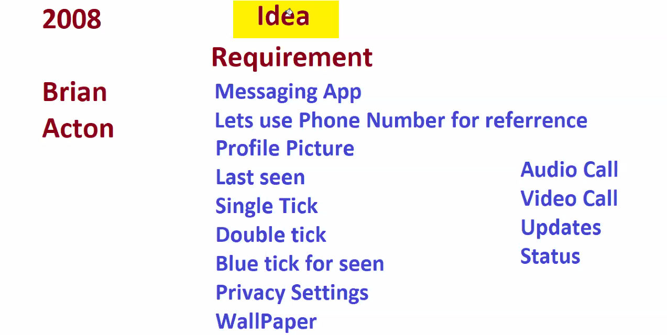
Once the Business is done with his requirements they hire Business Analyst, who closely works with idea guy or boss.

Then Hire 3 managers, i. Dev Manager, ii. ops Manger, iii, Test Manager. Then each manager hires there team based on tech requirements.
Dev Manager and Test Manager works closely with Business analyst. Dev manager asks his team to develop code for requirements, meanwhile testing team writes Test Cases for requirements.
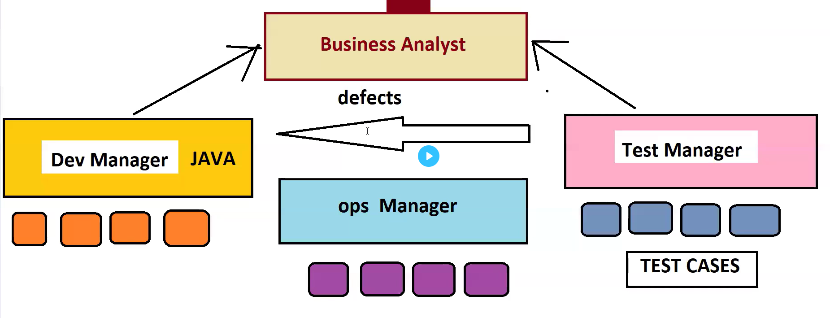
Once Dev team completes his development, Takes Dev/QA Server, runs the code, taking code to server will be assisted by ops manager. Once the code started running, then testers will connect to server and download the application and tests each and every functionality, by executing test cases. If testers find anything broken/bugs they immediately raise defects to Dev team. Then Dev team works on the defect then commit the code to server again. Again testing will be done in Dev/ QA server.
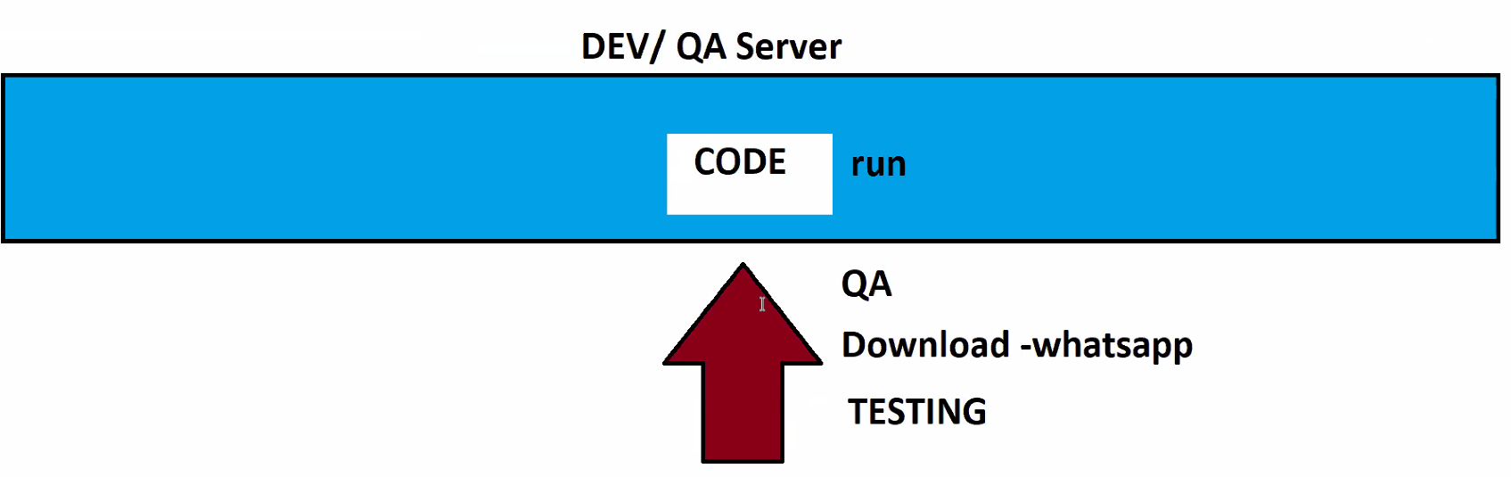
Once code gets tested in Dev/QA server, code will be deployed again in Pre live Server. Then testers again the testcases. If they find bugs they raise defects. If everything is fine, upon getting approval from Boss, they take final copy of code and run it in LIVE server.

If any issue happens in live server, it creates lots of business loss. In past, WhatsApp was down for 7 hours in live, which made loss of 1.25Billion Dollar loss.
Data Info Deep:
We are generating the data everyday to Google but not uploading or downloading the data. Examples: Lots of shopping in Amazon, Flipkart, Food delivering apps Swiggy, Zomato. Etc.

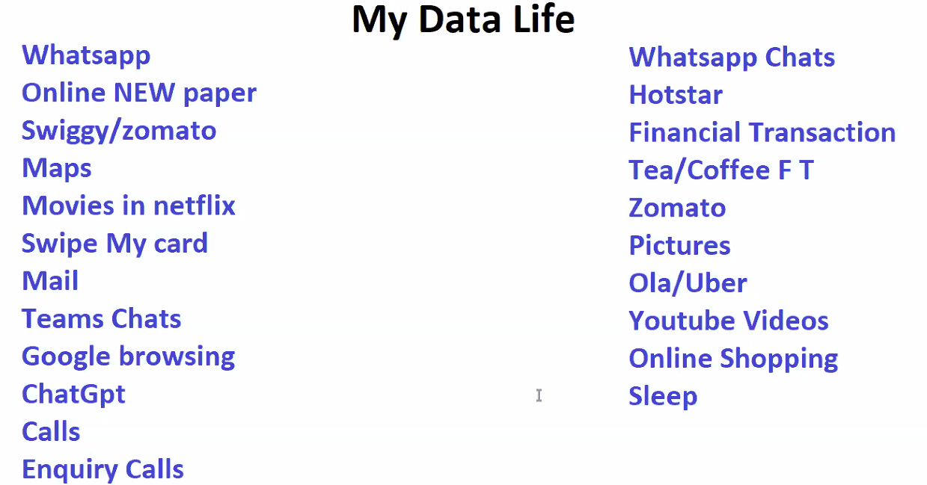

Two Real time use cases of Big Data Analytics:
- Data Analytics, by (Mark Zuckerberg + Cambridge Analytics) made Trump to win Elections in 2016.
- 2014 FIFA Final – Germany Vs Argentina. Germany won because of Big Data Analytics.
Data Evolution:
1960 Data used to be stored in TXT files(Notepad).
1970 Data started increasing a lot, notepad cannot suffice. DMBS got introduced. DMBS in today is ‘EXCEL’. First DBMS is called ‘VISICALC’. Calculations are very easy in Excel.
1980 Even notepad, DMBS cannot suffice data, A person known as Larry Ellison launched RDBMS. But it’s a paid version & people started paying huge money to Larry.
1990 Data increased, population increased, RDBMS cannot withstand the increasing Data. Then Larry again launched Data Warehouse along with RDBMS. Larry asked users to place less used in warehouse and highly used data in RDBMS. When required do migration from warehouse to RDBMS. Asked users to pay for warehouse also.
1995 Doug Cutting looking at Data Analytics(which is highly priced) launched DFS(Distributed File System). DFS was good at storage as it does distributed data storage, but failed at processing, as it brings back data from all Data nodes to Gateway node/server which burden’s the Gateway laptop. DFS failed.
2003 After 8 years, Google released paper on GFS(Google File System).
2004 Google release paper on MapReduce. Upon Reading MapReduce paper Doug Cutting was Shocked.
2005 Doug Cutting Designed similar MapReduce for DFS.
2006 Named (DFS & MapReduce) together as Hadoop(his Son’s Elephant Doll Name).
2007 Hadoop becoming Biggest hit. Everyone started using it.
2008 MapReduce looked so tough to understand. So, Facebook released HIVE. Data ingestions are very tough, so SQOOP was launched.
2009 Installing Hadoop, Sqoop, Hive Maintenance, upgrade are tough. Cloudera come forward and helped with Installation, Maintenance, upgrades setup in own laptops.. Asked to pay in return for all.
2012 Horton Works, stated we will do installation for free and have to pay for Maintenance and upgrades.
2014 Big super power was launched and many famous tools got vanished. That is SPARK.
2017 Cloudera completely bought Horton Works.
Parallely, when Hadoop is getting popular, another end there is something which is also getting popular. That is CLOUD COMPUTING.
2019 Cloud Computing stated, I’ll provide entire setup with giving laptops, installations(Hadoop, Hive, Sqoop, Spark), maintenance, upgrade. But PayMe for Rent, how much used.
2024 Cloud based Big Data Analytics powered with SPARK.
